Date: 11.02.2026
Group: 1-ОР-23
2/44 Lesson 22
teacher: Панкратова ЮВ
обратная связь: 9061900457 Max
Topic: Hand tools. Their components and functions. Ручной инструмент. Их составные части, функции.

Task 1. Translate these tools:
Переведите данные ниже названия инструментов с английского языка на русский.

Task 2. Vocabulary.
Составьте словарь (английское слово- транскрипция- перевод на русский язык).
См далее:

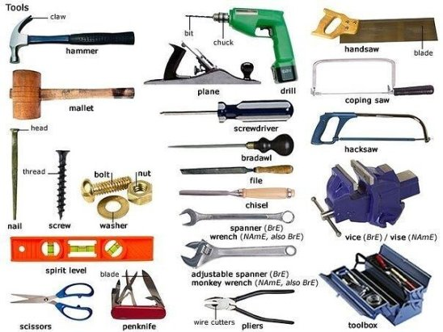

Task 3. Study the Vocabulary.
(записать словарь в тетрадь)
New Words:
tool | инструмент
toolbox | набор инструментов (ящик с инструментами)
power tool | электроинструмент
hammer | молоток
claw hammer | молоток с гвоздодером
handsaw | ножовка
saw | пила
crosscut saw | поперечная пила
sandpaper | наждачная бумага
plane | рубанок
drill | дрель
cordless drill (screwdriver) | шуруповерт
bits | биты (для шуруповерта)
vise | тиски
flathead screwdriver | плоская отвертка
Phillips screwdriver | крестообразная отвертка
awl | шило
file | напильник
chisel | зубило (долото)
wrench | гаечный ключ
crescent wrench | разводной ключ

Task 4. Read and translate the texts:

A corded drill is the only real power tool that we will be using in this class. While cordless drills get all the fanfare, corded drills give you the most bang for your buck - particularly for metalworking. You don't need to be particularly portable in the shop, and corded drills never run low on power. They also have a lot of torque, which is useful for metalworking. While they typically don't have all the fancy settings you may find on a cordless drill, these drills basically do one thing, and they do it very well.

When metalworking, you will want a hammer. If you have a standard claw hammer at home already, that will be fine for now. However, for metalworking you will eventually want to invest in a ball peen hammer and a dead blow. A ball peen hammer has a striking surface on one side, and a ball on the other for shaping metal. This is much more useful than a generic claw hammer, since you will unlikely have any nails that will need removing. In addition, a dead blow has a counterweight inside of the striking head that minimizes rebound and translates most of the force downwards onto the surface being struck. This is useful for shaping metal (amongst other things).

Иметь задание в наличии в рабочей тетради.
Задать вопрос по e-mail: grossbach@mail.ru

